Geospatial Info Solutions:
Admin Login collaboration Diagram

Admin
LoginPage
Business Object
DataAcessLayer
Database
1 : GetAdminHome()
2 : ValidateUser()
3 : ExecuteCommand
4 : ExecuteCommand()
5 : CommandResponse()
6 : Returns value()
7 : ResponseData()
Collaboration Diagram for add municipal taxes
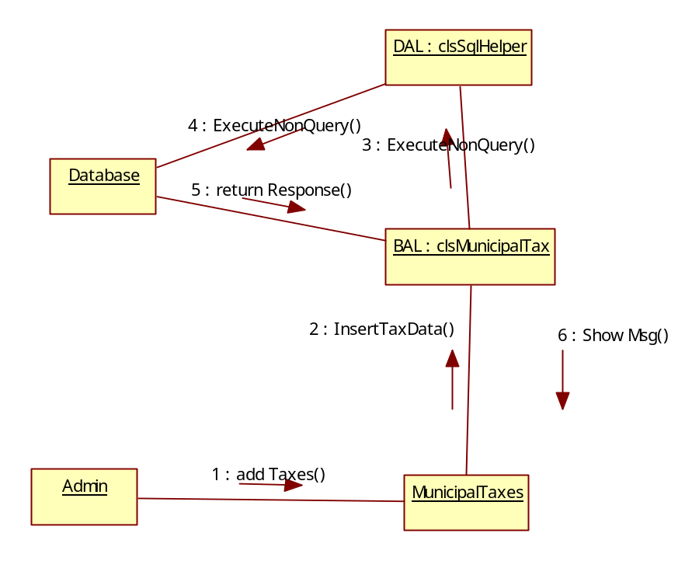
Collaboration Diagram for Add Local information

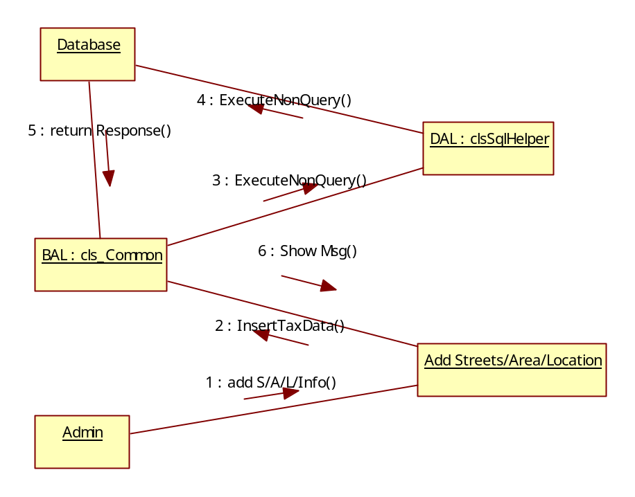

Collaboration Diagram for Building Approvals
Admin
Add BuildingApproval
BAL : clsBuildingApprovals
DAL : clsSqlHelper
Database
1 : BApprovals()
2 : InsertData()
3 : ExecuteNonQuery()
4 : ExecuteNonQuery()
5 : return Response()
6 : Show Msg()

Collaboration Diagram for Users Municipal Bills

